Assignment 3

# Exercise 1

How does normalizing affect accuracy of CART or Random Forest?

# Exercise 2

c) 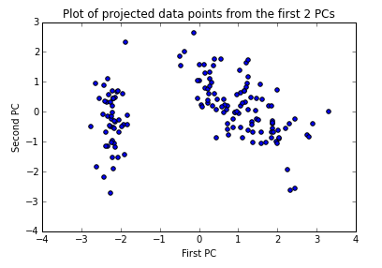

The plot seems to show 2 clusters.

d) 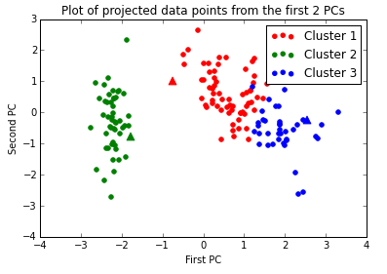

# Exercise 3

b) The test error of the logistic regression was 25.1%.

c) The test error of the optimal k-NN classifier was 24.1%. The k-NN classifier worked better on this dataset, but it was much slower compared to the logistic regression.